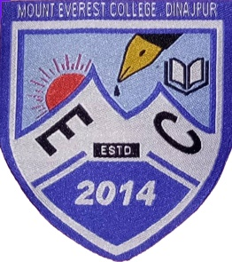**Mount Everest College**

Dinajpur Sadar, Dinajpur - 5200

Phone: +8801738-655144 , Web: www.mounteverestcollege.edu.bd

EIIN-138122

DATE:

**To Whom It May Concern**

This is to certify that **Md. Mojibur Rahman** , S/O Md. Lutfor Rahaman was teaching with us as a **Lecturer** for department of **Information and Communication Technology ( ICT )** in this college with effect from December, 2018 to October, 2019. His excellent research oriented teaching and command on the subject proved to be great asset to the students as well as to the institute. He is an excellent teacher having a deep and wide ranging understanding of the subject. He is an experienced and diligent teacher as well as a colleague.

To the best of our knowledge, he bears a good moral character and is not involved in such activities which are against the state freedom and peace.

We wish him all success and prosperity in his future life.

Principal